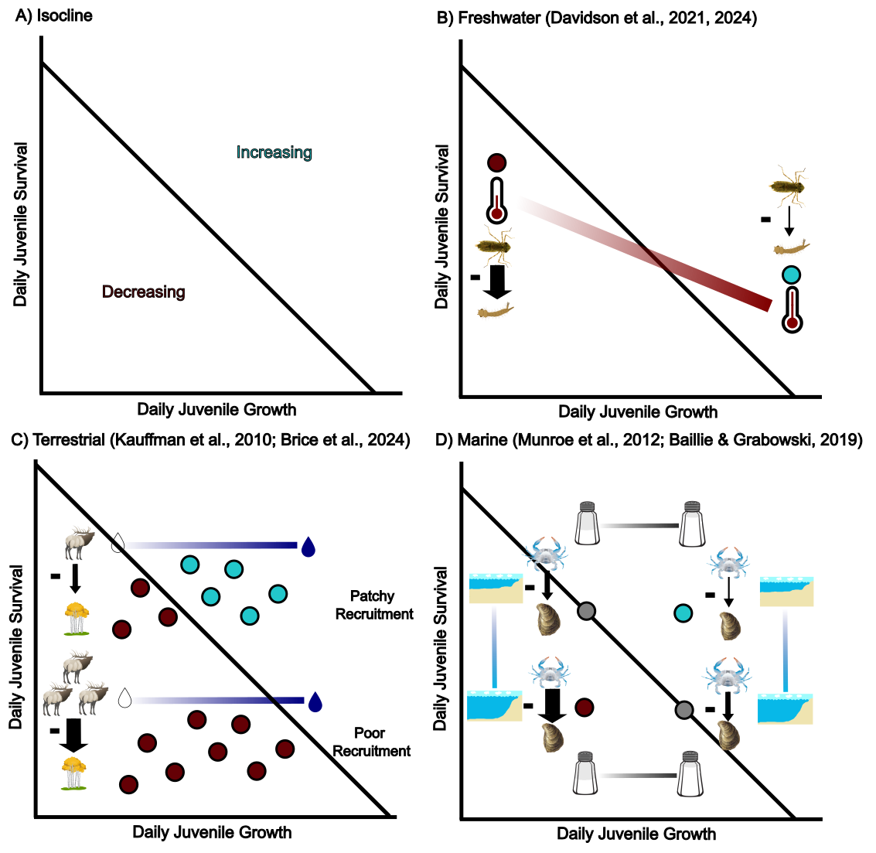

Figure 1 A) hypothesized zero-population growth isocline illustrating the joint impact of juvenile growth rates and juvenile mortality. Areas to the left and down of the line indicate populations are decreasing/not recruiting while areas above and to the right indicate populations are increasing/recruiting. B-D) Illustrated or hypothetical case studies spanning freshwater, terrestrial and marine ecosystems demonstrating how the isocline could give predictions about how top-down control is influenced by different environmental gradients. Points colored blue indicate populations are declining/not recruiting while points colored pink indicate populations are increasing/recruiting. B) The most likely relationship of a demonstrated example of top-down control of mosquito (*Aedes atropalpus*) populations by dragonflies (*Pantala* spp.) when predator consumption rates and prey growth rates are simultaneously influenced by a temperature gradient. C) Hypothetical spatial/temporal distribution of quaking aspen (*Populus tremuloides*) stand recruitment along a moisture gradient given high or low top-down control by elk (*Cervus canadensis*). D) Hypothetical scenarios of top-down control of eastern oysters (*Crassostrea virginica*) by their predators (crabs, snails, and fish) along depth and salinity gradients.